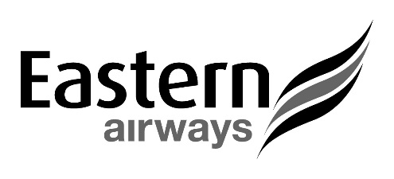
News release: Thursday 5 March 2020

EASTERN AIRWAYS TO OPERATE SCHEDULED FLIGHTS INDEPENDENTLY AND ALSO ANNOUNCES 3 NEW ROUTES

UK regional airline, Eastern Airways, will once again operate its own scheduled network of routes independently.
The privately-owned operator based at Humberside Airport will sell its scheduled routes through its own website – EasternAirways.com, and will continue to work closely with the travel trade following the announcement that its franchise partner, Flybe, has gone into administration.
The existing Eastern Airways network will continue to operate as normal and the airline will honour any tickets on Flybe services operated by Eastern Airways for travel today, Friday, Sunday or Monday. The airline will provide further updates for passengers with flights for next week.
Eastern Airways is offering a walk-up rescue fare of £60.00 including a bag for those affected passengers travelling today (5 March 2020) and Friday (6 March). It is only bookable at the airports and is subject to availability.
Eastern Airways is also to offer three new routes, formerly operated by Flybe, to provide certainty to key regions for the protection of services. Aberdeen-Birmingham, Southampton-Manchester and Southampton-Newcastle flights will all commence next week with the schedule released for sale imminently.
This complements the network of seven scheduled routes from Teesside International Airport to Alicante, Belfast City, Cardiff, Dublin, Isle of Man, London City, Southampton, as well as its existing Aberdeen service.
February also saw the Embraer 170 jet return to the Eastern Airways fleet as part of an expansion into the E-Jet fleet.
Tony Burgess, Managing Director of Eastern Airways, said: “We do extend sympathy to all Flybe staff and their families following the sad news that Flybe has ceased trading.
“As a former franchise partner of Flybe, this will not impact on any flights and routes operated by Eastern Airways. Revised booking facilities on Eastern Airways services will be advised on EasternAirways.com, which includes the quick recovery on Aberdeen-Birmingham, Southampton-Manchester and Southampton-Newcastle routes.
“Eastern Airways remains fully committed to providing regional connectivity with business links to capital cities and industrial centres.”
Formed in 1997, the airline operates a network of routes from airports including Aberdeen, Alicante, Anglesey, Belfast City, Cardiff, Dublin, Humberside, Leeds Bradford, London City, Newcastle, Southampton and Wick John O’Groats.
The airline also specialises in providing customer focused charter services for the oil and gas industry, corporate and sports contracts and ad-hoc charters.
ENDS

For information:
Darren Roberts, Eastern Airways Communications Manager
Tel: 01652 681425 or 07921 375211
Email: darren.roberts@easternairways.com

